To: |  |  | Council
Date: |  |  | 20 July 2020  (originally written for the cancelled 30 March 2020 meeting)
Report of: |  |  | Director of Development
Title of Report: |  |  | Partnership Update– Oxfordshire Local Enterprise Partnership
 | Summary and recommendations
 | Purpose of report: |  |  | To provide members with an update on the progress and impact of the Oxfordshire Local Enterprise Partnership (OXLEP).
 | Key decision: |  |  | No
 | Cabinet Member with responsibility: |  |  | Cllr Susan Brown, Leader of Oxford City Council and Economic Development Portfolio holder
 | Corporate Priority: |  |  | Fostering an Inclusive Economy
 | Policy Framework: |  |  | Economic Development Strategy
 | Recommendation: That Council:
 | 1. | Comments on and notes the report.

Appendices
Appendix 1 | Addendum to Council Report – OXLEP Update since March 2020
Appendix 2 | OXLEP factsheet

Introduction and background
- Now operating for nine years, Oxfordshire Local Enterprise Partnership Ltd (OxLEP) is the the over-arching local partnership promoting economic growth, and shaping the strategic direction of the Oxfordshire economy. Chief Executive, Nigel Tipple leads a team of staff who work closely with a network of business representatives, further and higher education representatives, and Economic Development officers.
- Jeremy Long was appointed as Board Chair in March 2016. He is currently Chief Executive for Europe of the Hong-Kong headquartered international railway and property group MTR Corporation, and has played a role in positioning the importance of Oxford Station. Cllr Susan Brown is the City Council’s OXLEP Board member, alongside the other council leaders across the county. Peter Nolan, formerly of Oxford BioMedica sits on the OXLEP Board and also chairs the Oxford Economic Growth Board (Oxford Strategic Partnership sub-group), providing a direct link between the city’s interests and the wider OXLEP area. Phil Southall, Managing Director of the Oxford Bus Company, and Penny Rinta-Suksi, Partner at Blake Morgan are also Oxford based members of the Board covering transport issues and programmes.
- City Council Officers remain involved in a range of OXLEP partnerships, and OxLEP colleagues are involved in many city and district partnerships. There is ongoing officer involvement and engagement with the LEP through various officers and teams including Directors, Regeneration and Economy, Planning, Sustainability, and Welfare Reform. LEP related partnerships that have involved city council officers over the last twelve months include;
  - The Local Industrial Strategy Steering Group
  - Oxfordshire Skills Board (Skills Advisory Panel)
  - Oxfordshire European Structural Investment Funds Committee
  - Joint Oxfordshire Business Support Group
  - Tourism Zone working group
- The LEP is also involved in supporting the following partnership and policy areas;
  - The Oxford-Cambridge Arc.
  - The Oxfordshire Growth Board
  - The Oxford Strategic Partnership
  - The Oxford Economic Growth Board
- The LEP’s Governance Structure and main strategic groupings are highlighted below:
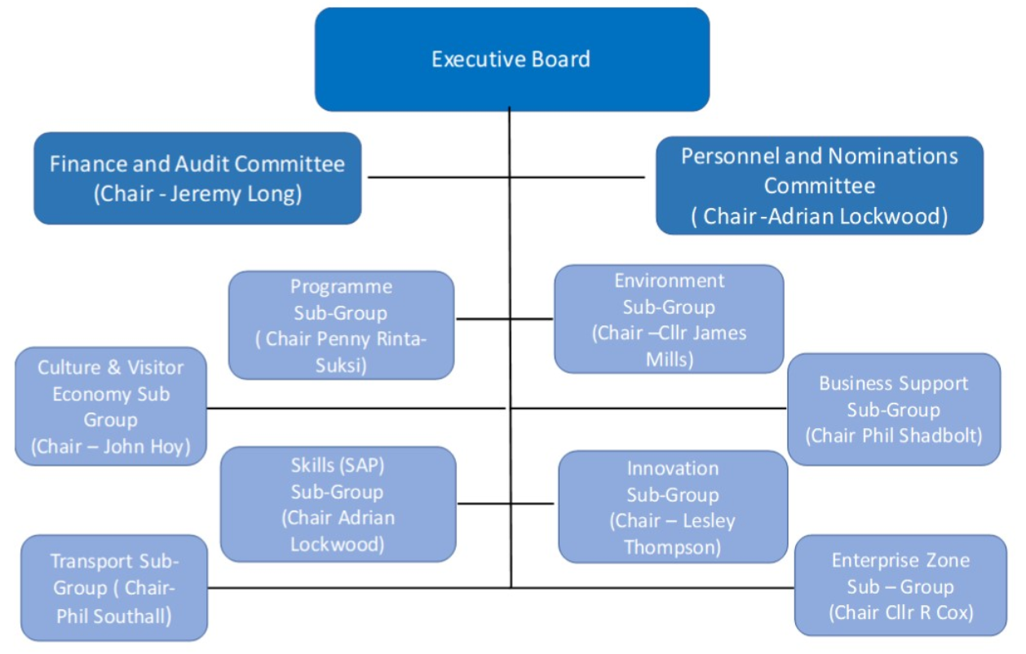

OxLEP Partnership Highlights 2019-2020
The Oxfordshire Industrial Strategy (LIS) was published in July 2019. The ambition for the Oxfordshire Local Industrial Strategy is to position the county as one of the top-three global innovation ecosystems, highlighting the world-leading science and technology cluster and to be a pioneer for the UK and our emerging transformative technologies and sectors. It also contains a commitment to Inclusive, low carbon growth. The partners are now working on the Delivery Strategy and Investment Prospectus for the key projects and initiatives in the strategy. Key among these involving council officers are proposals around
  - The West End Innovation Quarter
  - The Inclusive Economy Commission
  - Developing a business case to test the need for an Oxford Creative Industries Hub
  - Oxford Science Park expansion and Cowley Branch Line
  - Defining Oxfordshire Living Lab proposals on energy, mobility and health, with a range of county-wide partners
Working with officers, OXLEP has identified an additional £5m (now £10m) and aligned this with the indicative programme for delivery of the West Side Improvement at Oxford Station, including the Botley Bridge replacement. This will support the R£145-65m bid by Network Rail to Dept. for Transport to deliver the scheme. The LEP have been active in supporting partnership efforts to bring forward Oxford Station and other vital infrastructure to enable developments in Oxford’s West End.
Very recently, OxLEP has also awarded £1.93m to the City Council for the creation of entrepreneurship and enterprise workspaces in Oxford City centre. A portfolio of spaces is being reviewed by officers as part of a Workspace Assessment and Feasibility exercise. This could create around 10,000 sq. ft. of new space and support 160 local jobs in the city centre.
The Oxfordshire Inclusive Economy Seminar Series has bought a range of delegates together on research, policy and data on economic and social inequality to define the real scale of the challenge and highlight potential interventions to be developed through the seminar series and beyond. Whilst the Oxford Strategic Partnership and City Council have led this work, OxLEP has worked closely alongside to devise this seminar series, and will continue to on the formation and resourcing of the Inclusive Economy Commission. Officers are also working with the Chair of the LEP, Director of Strategy, and Skills team and short and longer term interventions to follow.
European Structural and Investment Funds (ESIF): OxLEP has been administering this €19.3m programme from 2014-2020. Launched in 2018, Innovation Support for Business (ISfB) is a £5.2m programme run in Oxfordshire by OxLEP Business to support eligible start-ups as well as small and medium enterprises (SMEs). Finance for the programme has been provided by the European Regional Development Fund (ERDF) with match funding from our local partners. It has enabled improved access to experts and collaborate with research institutes to commercialise new ideas and introduce new innovations to businesses. OxLEP is delivering the ISfB programme with partners from the University of Oxford, Cherwell District Council, Oxford City Council, and Oxford University Hospitals NHS Foundation Trust. It will finish in September 2020.
Existing programmes involving Oxford City Council include the £3.2m ‘OxFutures’ Low Carbon Economy Programme, £586K community grant European Social Funds to boost employability skills and Building Better Opportunities (£734K) in conjunction with Lottery Funds focussing on supporting those not in training education or employment (NEETs). The LEP played a role in securing these through its ESIF strategy and administering the ESIF process at a local level alongside central government. These programmes are all set to finish in the coming months.
It should be noted that this funding source will cease completely, as a) the programme form 2014-20 ends, and b) The UK leaves the EU. There is a vital requirement to look at resourcing of business support and skills/employability programmes in future. The United Kingdom Shared Prosperity Fund is the key fund intended to replace Structural Funds with a UK funding system. This UK Shared Prosperity Fund is intended to reduce inequality between communities across the four nations and to deliver sustainable, inclusive growth. £500 million was highlighted in the current Government’s Election Manifesto. Depending on how this is distributed across the UK, there may need to be novel local approaches to resourcing the type of business and skills support typically provided through Structural Funds.
Business Support (Growth Hub): from a Local Enterprise Partnership point of view, the £10m investment announced in March 2020 Budget, into England’s growth hubs announced offers some encouragement, allowing continuation of core business advice, resilience and guidance in uncertain times for small business communities.
Skills Board and programmes: Some of the key activity overseen by the Oxfordshire Skills Board includes;
  - Oxfordshire Careers Hub OxLEP is a Careers Hub as part of the Careers and Enterprise Company). 24 from 40 schools are part of the careers hubs and the aim is to increase the quality and depth of careers education across the eight Gatsby benchmarks. There are demonstrable improvements on these benchmarks county-wide, but long term concerns over resource and funding. It looks likely government support will continue but the level of support is uncertain and this will shape the level of impact in this important area to shape school leaver career choices.
  - LIS related Skills projects being worked up include a bid of £18m over 5 years to include all 53 schools and 3 colleges in the hub focussing on improving careers advice further, requesting new resource ring-fenced for career leader time. A £3.5m Apprenticeships and T-Levels (Technical Levels) promotion programme for staff to link providers and employers, unlocking more apprenticeship levy funds. Officers will support these efforts where possible.
  - The LEP’s 4th Apprenticeship Awards, a growing flagship event, aimed to promote quality apprenticeships among business, was recently postponed due to COVID-19. Officers will work to support the LEP with the event when it is rearranged.
- Linked to above, officers are working closely with the LEP on all business support issues related to the impact of COVID-19. This will cover communication to business on all available support, intelligence gathering on impact, and engagement with banks and businesses on further support needs. An OxLEP webinar for business on COVID-19 is planned for early April.

Financial implications
- There are no financial implications arising from this report.

Legal issues
- There are no legal implications arising from this report.

Level of risk
- N/A

Equalities impact
- N/A

Conclusion
- In general, Oxford City Council has a very positive partnership relationship with OxLEP’s key staff, teams and Boards. This is directly supporting local business, shaping policy and earmarking funds for key initiatives in Oxford. Some of the main highlights and wider statistics on county-wide impact can be found in OxLEP’s most recent annual report (linked below), and Factsheet, attached as a background paper.

Report author | Matt Peachey
Job title | Economic Development Manager
Service area or department | Economic Development
Telephone | 01865 252021
e-mail | mpeachey@oxford.gov.uk

Background Papers: None
1 | OxLEP Annual Report – Published April 2019

